MANUSCRIPT FORMAT FOR
THE INTERNATIONAL CONFERENCE ON COMMUNITY DEVELOPMENT
SYNERGIZING DIGITAL INNOVATION, ENTREPRENEURSHIP, AND SUSTAINABLE TOURISM FOR COMMUNITY DEVELOPMENT: STRATEGIES AND APPLICATIONS
(Times New Roman 12)
First AUTHOR^{1*}, Second AUTHOR², Third AUTHOR³ and Last AUTHOR^{n} (Times New Roman 10)
¹Affiliation of first author
^{2-n}Affiliation of second to last author
*Email Address only for corresponding author
ABSTRACT (Times New Roman 11)

Abstract is written at first with the word of ABSTRACT in Times New Roman 11-point bold. Description in ABSTRACT uses Times New Roman 10-point and 1 space. The abstract length is 150-200 words, without reference and it explains the paper content in brief version but understandable. Abstract is written in 1 (one) paragraph and in the last part inserted the 4-5 keywords separated by comma (,) follows the abstract, as shown here.
Keywords: template, instructions, conference, publications

INTRODUCTION
For the writing of paper content, the template must be referred. It will make style and layout of the written paper easier. The author is required to express quantitatively the portrait, profile, and condition of the target audience involved in community service activities. The conditions and potential of the area in terms of physical, social, economic, and environmental aspects that are relevant to the activities carried out can also be described. Also describe the potential that is used as material for community service activities. The author is asked to formulate the problem concretely and clearly in this section. Explain the objectives to be achieved in the community service activity.

The ICCD Conference Committee expects that the authors follow these instructions, so the papers published in the conference proceedings are uniform, consistent and high-qualiy appearance. Therefore, your paper format should exactly follow this template. The committee will only include numbering, pagination and headings for Conference titles and groupings in the appropriate topic. The paper should be written in English.
The paper content includes abstract, introduction, method, results and discussion, conclusion, and references. The paper can be completed with acknowledgment

method
The method describes the stages of the research, including the research design, research procedures, and how to test and analyze the data. In describing the research method, it must be supported by references, so that the explanation can be accepted scientifically. Authors are required to present a literature review that is primary (references to journal articles and conference proceedings) and up to date (references published within the last 10 years).

RESULTS AND DISCUSSION
In this section, the findings should be separated by discussion. Findings or research results are not raw data, but data that has been processed/analyzed by certain methods. The discussion is the result of interpretation of data analysis, if necessary linked to relevant scientific theories/concepts in the literature review. Findings and discussions must answer the formulation of the problem and have the impact of new knowledge. The contents of the findings and discussion can be in the form of interpretation of the results of the discussion.

Also explain the future development opportunities. Articles can be strengthened with relevant documentation related to services or goods as outputs, or the main focus of activities. Documentation can be in the form of pictures of the application or implementation process, pictures of product prototypes, tables, graphs, and so on.

Figure And Table
Table and figure are centred in the position. The table title must be written over the table, and the figure title must be under the figure. Both are written in Times New Roman, 10 point. The font used in the table is Times New Roman 10 point and 1 space. Tables should be illustrated as simply as possible to avoid misprints. The Table and Figure must be referred in the paper. The Table and Figure are inserted as close as possible to the description that refers them for the first time. The numbering of the Table and Figure is arranged from the number 1 onwards. The example of table can be saw in the Table 1. Fonts for the information of the Figure should be Bigger and more visible, so it can be read easily.
Table 1. Optimal value for muffling mass = 20 t
 | Run 1 | Run 2 | Run 3 | Run 4
c_{d} (kN-sec/m) | 35.251 | 35,259 | 35,261 | 35,266
k_{d} (kN/m) | 782,12 | 782,23 | 782,22 | 782,22
Objective funnction | 3,6589 | 3,6589 | 3,6589 | 3,6589
ω_{d} (rad/second) | 6,254 | 6,254 | 6,254 | 6,254

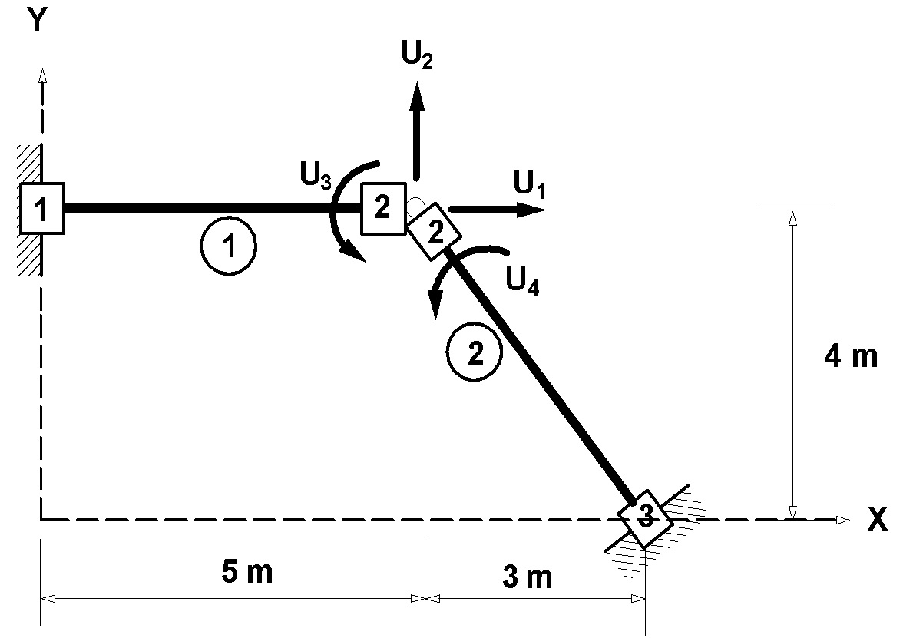
Figure 1. Model and freedom degree with the edge of the rod in rigid rod

CONCLUSION
Each paper must end with a conclusion summarizing the results of the paper. The conclusion should clearly indicate the results obtained, their strengths and weaknesses, and the possibility of further development.
By following the instructions, you greatly help the ICCD Conference Committee by lightening our workload and ensuring that your conference papers are presented impressively.

ACKNOWLEDGMENT (if any)
Title of acknowledgment section must be written without section number. Acknowledgments should be written simply 50-100 words. The research funder is usually mentioned, including the contract number, as this will also be as documentation for the funder that the activity has been published.

REFERENCES
References consist of journals (60%) of the total references. The minimum number of references is 10, all references must have relevance to research and come from the latest research (the last 10 years). References are written in APA style and arranged alphabetically. There is no name of the author of the reference source that still uses et al (all authors must be mentioned). The way of writing and abbreviating names is consistent and does not cite internet sources from Wikipedia. Authors are required to use applications such as Mendeley, Endnote and Zotero in compiling references. See examples of technical provisions for writing the following references:

Creswell, J. (2017). Qualitative Inquiry and Research Design: Choosing among Five Tradition (4th ed.). Sage Publications.
Kalamar, D. (2016). Convergence of Media and Transformation of Audience. Informatol, 49(3–4), 190–202.
Nasrullah, R. (2015). Media Sosial: Perspektif Komunikasi, Budaya, dan Sosioteknologi. PT Remaja Rosdakarya.
Putri, C. E., Damayanti, N., & Hamzah, R. E. (2020). Sadfishing Phenomenon of #Justiceforaudrey (Hashtag) on Twitter. Mediator: Jurnal Komunikasi, 13(1), 58–67. https://doi.org/10.29313/mediator.v13i1.5598
Suratnoaji, C., Arianto, I. D., & Sumardjijati. (2018). Strength map of presidential candidates 2019 in indonesia based on a nodeXL analysis of big data from twitter. Asian Journal for Public Opinion Research, 6(1), 31–38. https://doi.org/10.15206/ajpor.2018.6.1.31

Pagination
The paper must be written in the A4 paper size (21 cm x 29.7 cm) only. It has mirror margin, top 30 mm, bottom 25 mm, left (inside) 25 mm and right (outside) 20 mm. The paper content must be written in Times New Roman 10-point and 1 space. It uses the MS Word template. The paper should have 6 - 8 pages. The template instructs to have mirror margin for the even and odd number, so the author should not change the existing format.

Title And Authors
The title must be written in Times New Roman 12-point bold and centred as written in the template. All authors must be mentioned without any academic titles, 10-point, bold using comma to separate and for the last author separated with the use of “and” word. All authors are required to write down their affiliations. Corresponding author must provide email address. Affiliations are written under all authors' names in Times New Roman, 10-point italic.

Abstract writing
Each paper must have abstract with total amount of 150-200 words followed by keywords. It has to be a brief description of the problem, approach, results and conclusion of the work. The abstract format includes background, objective, methods, results and conclusion.

Paper Content: 10 Point, Paragraph Title (Heading) 11 Point
Papers must be written in Times New Roman 10 point, justified, and 1 space as set out in the document. Authors are allowed to use other types of fonts for special purposes, for example in differentiating source code for computer programs. The title of section (heading of the section) is written in Times New Roman Capital, 11 point bold. The numbering starts from the number of 1, 2, 3 and so on. The paragraph format is justified, and in the upper and lower side of one page must be full, so the remaining space can be adjusted. The alinea replacement must be written in 1 space.
Subheading
Title of subsection must be written up Times New Roman 11 point bold and it is written in the model of sentence case (Capital only for the first word). Title of subsection must be written without chapter number.
Page number, header and footer
All papers submitted by the author are expected to not include page numbers and footnotes. The ICCD Conference Committee will bind all papers when they have been received.

